1.The part of the earth that is made up of water is known as
A. Ocean
B. Hydrosphere
C. Sea
Atmosphere
2.The following are main features of the hydrological cycle except
A. Sun
B. Water masses
C. Vegetation
D. Evapo-transpiration
3. The process whereby the rain water enter into the soil is called
A. Precipitation
B. Infiltration
C. Run-off
D. Percolation
4. The movement of water from the ground to the atmosphere through plans is called
A. Photosynthesis
B. Transpiration
Evaporation
D. Hydrosphere
5.What causes day and night
A. Movement of the sun from east to west
Movement of the earth on its axis
Movement of the earth around the sun
D. Movement of both the earth and the sun
6.Contour lines join places of the same
A. Temperature
Pressure
Humidity
D. Altitude
7.How does water cycle help students in schools
A. It provides water for domestic use
B. It waters teacher’s maize in the field
C. It gathers garbage to be swept by the students
D. It destroys flowers students plant in schools
8The process of planting trees where they have been cut is called
A. Deforestation
B. Afforestation
C. Agroforestry
D. Reforestation
9. Which of the following is a largest scale
A. 1:10000
B. 1:20000
C. 1: 25000
D. 1:50000
10. Which of the following is not an example of artificial environment
A. Houses
B. Roads
c. railways
D. Mountains
11. Which of the following defines ecosystem
A. The accumulation of gases in the atmosphere
B. Present of water, air and wind that has been purified from the atmosphere
C. a community where all the living things interact and multiply increasing the population of animals
D. A community where living things and non-living things live, feed, produce and interact with the environment
12. Which of the following settlements has huts located far away from each other
A. Linear scale
B. Circular
C. Isolated
D. Nuclear
13. What instrument is used to measure air pressure
A. Mercury
B. Barometer
C. Wind vane
D. Haumea
14.which of the following gases is added to the atmosphere by animal respiration
A. Nitrogen
B. Argon
C. Carbon dioxide
D carbon monoxide
15.The following is the lowest layer of the atmosphere from the earth
A. thermosphere
B Stratosphere
C. Troposphere
D. Mesosphere
16.Which of the following is not a way of maintaining the biosphere
A. Afforestation
B. Civic education
C. use of alternative source of energy
D. Use of firewood and charcoal
17.whoch of the following cannot be found on the map
A. Location
B. current time
C. Direction of places
D. Natural features
18.The movement of ground water in the saturated zone below the Earth's surface is called
A. Evaporation
B. Percolation
C.Evapo-transpiratipn
D. Infiltration
19.why Pluto is not considered as a planet
A. It is the biggest planet
B. It is a dwarf planet
C. It contains a lot of gases which cannot be removed
D. It is far from the sun
20. Revolution of the earth causes_________
A. Day and night
B. Rains
C. Seasons
D. Causes climate, sunrise and sunset

SECTION B
21.a. Define hydrological cycle
__________________________________________________________________________________________________________________________________________________________________________ (2 marks)
B. Explain any two processes of the hydrological cycle
_________________________________________________________________________________________________________________________________________________________________________________________________________________________________________________________________________________________________________________________________________________(4 marks)
22. Outline any two developments related to the solar system
___________________________________________________________________________________________________________________________________________________________________________________________________________________________________________________________________________________________________________________________________________(4 mark
B. Describe why Pluto was removed on the list of planets
__________________________________________________________________________________________________________________________________________________________________________ (2 marks)
23.a. Explain what do you think would happen if there were no gases in the thermosphere
__________________________________________________________________________________________________________________________________________________________________________________________________________________________________________________(2 marks)
B. Why is Oxygen mostly important gas on earth
_____________________________________________________________________________(1mark)
24. Study the figure 1 below and use it to answer the questions that follows
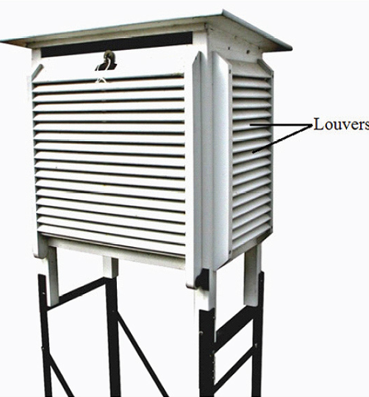

A.Why is the box painted white
________________________________________________________________________________________________________________________________________________________ (1 mark)
B.Name two instruments that are contained in the diagram above
_____________________________________________________________________________________________________________________________________________________________(2 marks)
C .describe two factors to consider when setting up the box
_______________________________________________________________________________________________________________________________________________________________________________________________________________________________________________________________________________________________________________________________________(4 marks)
25.a. Describe two ways in which humans have adversely affected natural ecosystem
___________________________________________________________________________________________________________________________________________________________________________________________________________________________________________________________________________________________________________________________________________(4 marks)
B. why are decomposers important in the ecosystem
____________________________________________________________________________________________________________________________________________________________ (2 marks)
26. Draw the water cycle and on it show three processes of the water cycle and two features (7 marks)

27.a. Explain any two components of the natural environment
_______________________________________________________________________________________________________________________________________________________________________________________________________________________________________________________________________________________________________________________________________________(4 marks)
B. Why are animals one of the important resource in the environment
______________________________________________________________________________________________________________________________________________________________(2 marks)
28. With examples, explain the difference between biotic and abiotic components
__________________________________________________________________________________________________________________________________________________________________________________________________________________________________________________________________________________________________________________________________________________(4marks)
26. Study the figure 2 below and use it to answer the questions that follows
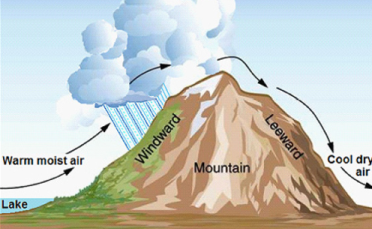
A.Name the type of rainfall portrayed in the diagram above
_________________________________________________________________(1 mark)
B.explain how this type of rainfall is formed
____________________________________________________________________________________________________________________________________________________________________________________________________________________________________________________________(4 marks)
c. Which side is expected to receive more rains and why
____________________________________________________________________________________________________________________________________________________________________________________________________________________________________________________(3 marks)
Section C
29.explain any four ways in which the biosphere is important
______________________________________________________________________________________________________________________________________________________________________________________________________________________________________________________________________________________________________________________________________________________________________________________________________________________________________________________________________________________________________________________________________________________________________________________________________________________________________________________________________________________________________________________________________________________________________________________________________________________________________________________________________________________________________________________________________________________________________________________________________________________________________________________________________________________________________________________________________________________________________________________________________________________________________________________________________________________________________________________________________________________________________________________________________________________________________________________________________________________________________________________________________________________________________________________________________________________________________________________________________________________________________________________________________________________________________________________________________________________________________________________________________________________________________________________________________(8 marks)
30.Describe three ways in which the water cycle can be maintained
______________________________________________________________________________________________________________________________________________________________________________________________________________________________________________________________________________________________________________________________________________________________________________________________________________________________________________________________________________________________________________________________________________________________________________________________________________________________________________________________________________________________________________________________________________________________________________________________________________________________________________________________________________________________________________________________________________________________________________________________________________________________________________________________________________________________________________________________________________________________________________________________________________________________(6 marks)

30.Describe any four proofs that show that the earth is spherical in shape
_____________________________________________________________________________________________________________________________________________________________________________________________________________________________________________________________________________________________________________________________________________________________________________________________________________________________________________________________________________________________________________________________________________________________________________________________________________________________________________________________________________________________________________________________________________________________________________________________________________________________________________________________________________________________________________________________________________________________________________________________________________________________________________________________________________________________________________________________________________________________________________________________________________________________________________________________________________________________________________________________________________________________________________________________________________________________________________________________________________________________________________________________________________________________________________________________________________________________________________________________________________________________________________________________________________________________________________________________________________________________________________________________________________________________________________________________________________________________________________________________________________________________________________________________________________________________________________________________________________________________________________________________________________________________________________________________________________________________(9 marks)
End of question paper

